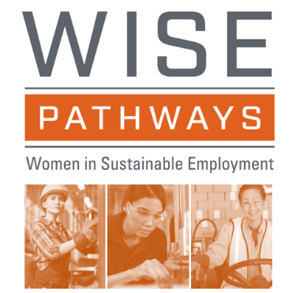
Women In Sustainable Employment (WISE) Pathways is a career exploration program designed for women to learn about in-demand technical jobs, sometimes referred to as middle-skill STEM careers, such as those in the manufacturing, supply chain, IT, energy, utilities, public safety, construction, and other skilled occupations. The program covers the realities of the featured careers, what to expect and how to be competitive in a hiring process, and where to get needed education and training. The COVID 19 pandemic has negatively affected women who lost retail, hospitality, and other jobs in the economic downturn. These challenging times provide an opportunity for women to learn about in-demand, high wage careers that can provide stability for themselves and their families.

Participants have the chance to engage in career exploration and coaching with role models to help them picture themselves in target industries. WISE Pathways combines two proven techniques to engage women and raise awareness of in-demand careers in their community that provide a family-sustaining wage:

- Career Exploration and Coaching with engaged industry and education partners
- Trained Role Model Speakers

Originally developed by HHW Ohio, the program has been through frequent iterations and improvements through partnerships with public and private organizations including AmeriCorps, the Center for Energy Workforce Development and others, and with investments from the US Department of Labor and other public and private supporters. Beginning in 2016, HHW Ohio partnered with Lorain County Community College and SkillsCommons to make WISE Pathways a free, open education resource available nationally. WISE Pathways is designed to be hosted by many types of organizations and relies on a partnership model where host organizations coordinate content as well as needed supports for participants. Community-based organizations, workforce/economic development agencies, educators, and industry partners collaborate to deliver this program. After completing the WISE workshop, these organizations may offer additional services, which will help program completers along their pathway, such as entering needed education and training, preparing for entry-level jobs or apprenticeship programs.
Through its leadership of Ohio TechNet, launched in 2014 with a USDOL TAACCCT grant, Lorain County Community College (LCCC) worked with SkillsCommons and subject matter experts from targeted industries to create or enhance many “Grab and Go” resources for utilization in launching a WISE Pathways pilot. To support engagement of women in the Ohio Manufacturing Workforce Consortium, supported by a USDOL Scaling Apprenticeship grant, LCCC and partners from the Ohio Manufacturers’ Association are assisting regions in the launch of WISE Pathways pilot programs. The enhanced WISE Pathways resources are free to use and customizable for any region; examples include a county court system partnering with education, workforce, and industry to offer WISE Pathways as a diversion program for women who are first time, non-violent offenders; an Appalachian community offering WISE Pathways to those completing drug rehab; an urban neighborhood hosting WISE Pathways in a community training center which has a computer lab and childcare options; and a small rural college opting to offer WISE as two weeklong summer camps, one for young women after their junior year in high school and one session for un/underemployed women ages 18 - 50+.
HHW Ohio remains a valued partner, sharing its expertise to engage and prepare Role Model Speakers, as well as building a library of Role Model Speakers videos and an online Role Model Speaker training. Two videos were recently completed: Female Apprentice hired by Spence Technologies, Inc., a women-led manufacturer; and Female Autoworker shares her leadership story. Other partners, such as Rhodes State College, have also created videos that they have produced to encourage more women to consider apprenticeships. Another important partner is the National Laboratory for Education Transformation (NLET), which is coordinating the further digitization of the WISE curriculum and the creation of a WISE Pathways Impact Community website intended to offer access for women interested in independent exploration of interactive WISE Pathways resources, and a site for program hosts, coordinators, industry partners and others to connect and share resources, in support of open innovation and continuous improvement.

Interested in learning more about WISE Pathways? Contact Bernie Gosky: bgosky@lorainccc.edu.
To learn more about HHW Ohio and the Role Model Speakers Bureau, email director@hhwohio.org

